**BigData Assignment 5.3**

Find square root of number using Babylonian method.

Solution -

**object Babylonian_squareroot {**

**def root(n:Float): Float = {**

**//Assuming x is the square root of the no**

**var x:Float = n**

**var y:Float = 1**

**//To decide the precision**

**var e:Float = .00000f**

**while((x-y)>e){**

**//calculate average**

**x = (x+y)/2**

**y = n/x**

**}**

**//return output**

**x**

**}**

**def main(args: Array[String]){**

**println("Square root of "+args(0)+" is "+root(args(0).toInt))**

**}**

**}**

Input - 100

Output - 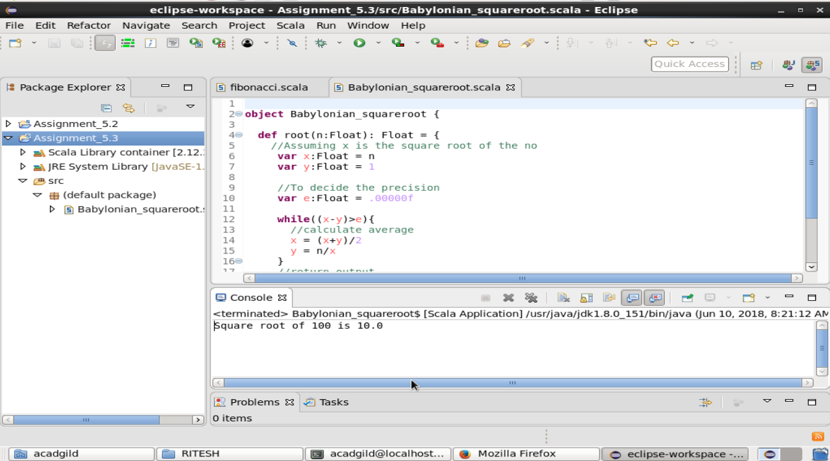 As in the below screenshot , in the console window it is visible that sqaure root of 100 is 10.0 which was calculated using Babylonian method.